Name: Ashish Kumar Mishra

Web-d (self-paced , march )

Html (FRONTEND):_________________________

<!DOCTYPE html>

<html lang="en">

<head>

    <meta charset="UTF-8">

    <meta http-equiv="X-UA-Compatible" content="IE=edge">

    <meta name="viewport" content="width=device-width, initial-scale=1.0">

    <link rel="stylesheet" href="./style.css" type="text/css" media="all">

    <title>Weather App</title>

</head>

<body>

    <div class="container">

        <div class="current-info">

            <div class="date-container">

            <div id="city">

              <div id="header">Weather Forecast</div>

              <p id="inputContainer">Enter Location: <br>

                <form action="/city" method="get">

                <input type="text" name="cityInput" placeholder="eg. delhi">

                <input type="submit" >

                </form>

            </p>

            </div>

                <div class="time" id="time">

                    12:30 PM

                </div>

                <div class="date" id="date">

                    Monday, 25 May

                </div>

                <div class="others" id="current-weather-items">

                    <h3 style="text-align: center; color: rgb(135, 135, 236); opacity: 0.5;">GET WEATHER UPDATE BY LOCATION</h3>

                    <form action="/location">

                    <input type="submit">

                    </form>

                </div>

            </div>

        </div>

    </div>

    <div class="future-forecast">

        <div class="today" id="current-temp">

            <img src="http://openweathermap.org/img/wn/{{day0img}}@2x.png" alt="weather icon" class="w-icon">

            <div class="other">

                <div class="day" id="day0">Monday</div>

                <div class="temp"  >Night:{{day0night}}&#176; C</div>

                <div class="temp" >Day:{{day0day}}&#176; C</div>

                <div class="temp" >Humidity -{{day0humidity}}</div>

                <div class="temp" >Wind speed -{{day0windspeed}}</div>

            </div>

        </div>

        <div class="weather-forecast" id="weather-forecast">

            <div class="weather-forecast-item">

                <div class="day" id="day1">Tue</div>

                <img src="http://openweathermap.org/img/wn/{{day1img}}@2x.png" alt="weather icon" class="w-icon">

                <div class="temp" >Night - {{day1night}}&#176; C</div>

                <div class="temp" >Day -{{day1day}}&#176; C</div>

                <div class="temp" >Humidity -{{day1humidity}}</div>

            </div>

            <div class="weather-forecast-item">

                <div class="day" id="day2">Wed</div>

                <img src="http://openweathermap.org/img/wn/{{day2img}}@2x.png" alt="weather icon" class="w-icon">

                <div class="temp" id="day2nighttemp">Night - {{day2night}}&#176; C</div>

                <div class="temp" id="day2daytemp">Day - {{day2day}}&#176; C</div>

                <div class="temp" >Humidity -{{day2humidity}}</div>

            </div>

            <div class="weather-forecast-item">

                <div class="day" id="day3">Thur</div>

                <img src="http://openweathermap.org/img/wn/{{day3img}}@2x.png" alt="weather icon" class="w-icon">

                <div class="temp" >Night - {{day3night}}&#176; C</div>

                <div class="temp" >Day - {{day3day}}&#176; C</div>

                <div class="temp" >Humidity -{{day3humidity}}</div>

            </div>

            <div class="weather-forecast-item">

                <div class="day" id="day4">Fri</div>

                <img src="http://openweathermap.org/img/wn/{{day4img}}@2x.png" alt="weather icon" class="w-icon">

                <div class="temp" >Night - {{day4night}}&#176; C</div>

                <div class="temp" >Day -{{day4day}}&#176; C</div>

                <div class="temp" >Humidity -{{day4humidity}}</div>

            </div>

            <div class="weather-forecast-item">

                <div class="day" id="day5">Sat</div>

                <img src="http://openweathermap.org/img/wn/{{day5img}}@2x.png" alt="weather icon" class="w-icon">

                <div class="temp" >Night - {{day5night}}&#176; C</div>

                <div class="temp" >Day - {{day5day}}&#176; C</div>

                <div class="temp" >Humidity -{{day5humidity}}</div>

            </div>

            <div class="weather-forecast-item">

                <div class="day" id="day6">Sun</div>

                <img src="http://openweathermap.org/img/wn/{{day6img}}@2x.png" alt="weather icon" class="w-icon">

                <div class="temp" >Night - {{day6night}}&#176; C</div>

                <div class="temp" >Day - {{day6day}}&#176; C</div>

                <div class="temp" >Humidity -{{day6humidity}}</div>

            </div>

        </div>

    </div>

    {{!-- <script src="https://cdnjs.cloudflare.com/ajax/libs/moment.js/2.29.1/moment.min.js" integrity="sha512-qTXRIMyZIFb8iQcfjXWCO8+M5Tbc38Qi5WzdPOYZHIlZpzBHG3L3by84BBBOiRGiEb7KKtAOAs5qYdUiZiQNNQ==" crossorigin="anonymous" referrerpolicy="no-referrer"></script> --}}

    <script >

        var citysearch ="delhi";

        var latitude;

        var longitude;

        const currentTime = document.getElementById("time")

        let currentdate = document.getElementById("date");

        const tempStatus = "clouds";

        const getCurrenttime = () =>{

            var now = new Date();

            let hours = now.getHours();

            let minutes = now.getMinutes();

            let ampm = "AM";

            if(hours>11){

                ampm  = "PM";

                if(hours>12){

                    hours-=12;

                }

            }

            if(minutes <10){

                minutes = "0" + minutes;

            }

            console.log(hours);

            return `${hours} ${":"} ${minutes} ${ampm}`;

        }

        const getCurrentTime= () =>{

            var weekday = new Array(7);

            weekday[0]= "Sunday";

            weekday[1]= "Monday";

            weekday[2]= "Tueday";

            weekday[3]= "Wedday";

            weekday[4]= "Thursday";

            weekday[5]= "Friday";

            weekday[6]= "Saturday";

            let currentTime = new Date();

            console.log(weekday[currentTime.getDay()]);

            var months =[

                "Jan",

                "Feb",

                "March",

                "April",

                "May",

                "June",

                "July",

                "August",

                "Sep",

                "Oct",

                "Nov",

                "Dec",

            ];

            var now = new Date();

            var month = months[now.getMonth() + 1];

            var day = now.getDate();

            console.log(month + '/' + day);

            document.getElementById("day0").innerHTML = weekday[currentTime.getDay()]

            document.getElementById("day1").innerHTML = weekday[(currentTime.getDay()+1)%7]

            document.getElementById("day2").innerHTML = weekday[(currentTime.getDay()+2)%7]

            document.getElementById("day3").innerHTML = weekday[(currentTime.getDay()+3)%7]

            document.getElementById("day4").innerHTML = weekday[(currentTime.getDay()+4)%7]

            document.getElementById("day5").innerHTML = weekday[(currentTime.getDay()+5)%7]

            document.getElementById("day6").innerHTML = weekday[(currentTime.getDay()+6)%7]

            return ` ${weekday[currentTime.getDay()]} ${", "} ${day} ${month}`;

        }

        currentdate.innerHTML =  getCurrentTime();

        currentTime.innerHTML =  getCurrenttime();

    </script>

</body>

</html>

JAVASCRIPT – (BACKEND) ____________________________________

// api key

// 840695df8e39e8e4efc9d8b05a02d0d0

// api get request

// https://api.openweathermap.org/data/2.5/forecast?id=524901&appid=840695df8e39e8e4efc9d8b05a02d0d0

// accessing data

const {Navigator} = require("node-navigator");

const navigator = new Navigator();

const bodyparser = require("body-parser")

const https = require("https");

const express = require("express");

const app = express();

app.set("view engine", "hbs")

app.use(bodyparser.urlencoded({ extended: true }));

app.use(express.static( __dirname +"/public"));

// set the server

const port = process.env.PORT || 3000 ;

app.listen( port , ()=>{

    console.log(`listening...${port} port`)

})

//home

app.get("/", async(req,res)=>{

    res.render("index");

});

//BY city

app.get("/city", async(req,res)=>{

    getcity =  req.query.cityInput;

    let urllink = `https://api.openweathermap.org/data/2.5/forecast?id=524901&appid=840695df8e39e8e4efc9d8b05a02d0d0&units=metric&q=${getcity}` ;

    https.get( urllink, (response)=>{

        response.on("data",   function(data){

        const weatherdata =  JSON.parse(data);

        let tempmax = Array(10);

        let tempmin =new Array(10);

        let humidity = new Array(10);

        let weathericon = Array(10);

        tempmin[0] = weatherdata.list[0].main.temp_min;

        tempmax[0] = weatherdata.list[0].main.temp_max;

        humidity[0] = weatherdata.list[0].main.humidity

        let windspeed = weatherdata.list[0].wind.speed

        weathericon[0] = weatherdata.list[0].weather[0].icon

        let j=0;

        for(let i =1; i<weatherdata.cnt; i++){

            if(weatherdata.list[i].dt_txt[11] ==='0' && weatherdata.list[i].dt_txt[12]==='0'){

                tempmin[j] = weatherdata.list[i].main.temp_min;

                tempmax[j] = weatherdata.list[i].main.temp_max;

                humidity[j] = weatherdata.list[i].main.humidity

                weathericon[j] = weatherdata.list[i].weather[0].icon

                j++;

            }

        }

        res.render("index", {

                // i am using dublicate data because it's not giving the required data. however, its working will be similar

                day0img: weathericon[0],

                day1img: weathericon[1],

                day2img: weathericon[2],

                day3img: weathericon[3],

                day4img: weathericon[4],

                day5img: weathericon[4],

                day6img: weathericon[4],

                day0windspeed : windspeed+" Kmph",

                day0night : tempmin[0],

                day1night : tempmin[1],

                day2night : tempmin[2],

                day3night : tempmin[3],

                day4night : tempmin[4],

                day5night : tempmin[4],

                day6night : tempmin[4],

                day0day : tempmax[0],

                day1day : tempmax[1],

                day2day : tempmax[2],

                day3day : tempmax[3],

                day4day : tempmax[4],

                day5day : tempmax[4],

                day6day : tempmax[4],

                day0humidity : humidity[0],

                day1humidity : humidity[1],

                day2humidity : humidity[2],

                day3humidity : humidity[3],

                day4humidity : humidity[4],

                day5humidity : humidity[4],

                day6humidity : humidity[4]

            });

        });

        response.on("end", function(err){

            if(err){

                console.log('error...');

            }

            else{

                console.log("end");

            }

        })

    });

})

//BY Location

app.get("/location", (req,res)=>{

    if (navigator.geolocation) {

        navigator.geolocation.getCurrentPosition((success, error)=>{

            if(error)console.log(error);

            else locdata(success.latitude, success.longitude);

        });

     } else {

       alert(" browser does not support the navigator function, please switch to another browser. thankyou!");

     }

function locdata(lat , long){

    // console.log(long,lat);

    let urllink;

    urllink = `https://api.openweathermap.org/data/2.5/forecast?id=524901&appid=840695df8e39e8e4efc9d8b05a02d0d0&units=metric&lat=${lat}&lon=${long}` ;

    https.get( urllink, (response)=>{

        response.on("data",   function(data){

        const weatherdata =  JSON.parse(data);

        let tempmax = Array(10);

        let tempmin =new Array(10);

        let humidity = new Array(10);

        let weathericon = Array(10);

        tempmin[0] = weatherdata.list[0].main.temp_min;

        tempmax[0] = weatherdata.list[0].main.temp_max;

        humidity[0] = weatherdata.list[0].main.humidity

        let windspeed = weatherdata.list[0].wind.speed

        weathericon[0] = weatherdata.list[0].weather[0].icon

        let j=0;

        for(let i =1; i<weatherdata.cnt; i++){

            if(weatherdata.list[i].dt_txt[11] ==='0' && weatherdata.list[i].dt_txt[12]==='0'){

                tempmin[j] = weatherdata.list[i].main.temp_min;

                tempmax[j] = weatherdata.list[i].main.temp_max;

                humidity[j] = weatherdata.list[i].main.humidity

                weathericon[j] = weatherdata.list[i].weather[0].icon

                j++;

            }

        }

        res.render("index", {

                // i am using dublicate data because it's not giving the required data. however, its working will be similar

                day0img: weathericon[0],

                day1img: weathericon[1],

                day2img: weathericon[2],

                day3img: weathericon[3],

                day4img: weathericon[4],

                day5img: weathericon[4],

                day6img: weathericon[4],

                day0windspeed : windspeed+" Kmph",

                day0night : tempmin[0],

                day1night : tempmin[1],

                day2night : tempmin[2],

                day3night : tempmin[3],

                day4night : tempmin[4],

                day5night : tempmin[4],

                day6night : tempmin[4],

                day0day : tempmax[0],

                day1day : tempmax[1],

                day2day : tempmax[2],

                day3day : tempmax[3],

                day4day : tempmax[4],

                day5day : tempmax[4],

                day6day : tempmax[4],

                day0humidity : humidity[0],

                day1humidity : humidity[1],

                day2humidity : humidity[2],

                day3humidity : humidity[3],

                day4humidity : humidity[4],

                day5humidity : humidity[4],

                day6humidity : humidity[4]

            });

        });

        response.on("end", function(err){

            if(err){

                console.log('error...');

            }

            else{

                console.log("end");

            }

        })

    });

}

})

PACKAGES_________________________

{

  "name": "major-project-1--ashish-kumar-mishra",

  "version": "1.0.0",

  "description": "",

  "main": "index.js",

  "scripts": {

    "dev": "nodemon weather.js"

  },

  "keywords": [],

  "author": "",

  "license": "ISC",

  "dependencies": {

    "body-parser": "^1.20.0",

    "chart.js": "^3.7.1",

    "express": "^4.18.1",

    "fs": "^0.0.1-security",

    "hbs": "^4.2.0",

    "navigator": "^1.0.1",

    "node-navigator": "^1.0.1",

    "nodemon": "^2.0.16",

    "request": "^2.88.2",

    "requests": "^0.3.0"

  }

}

DATA USING LOCATION: 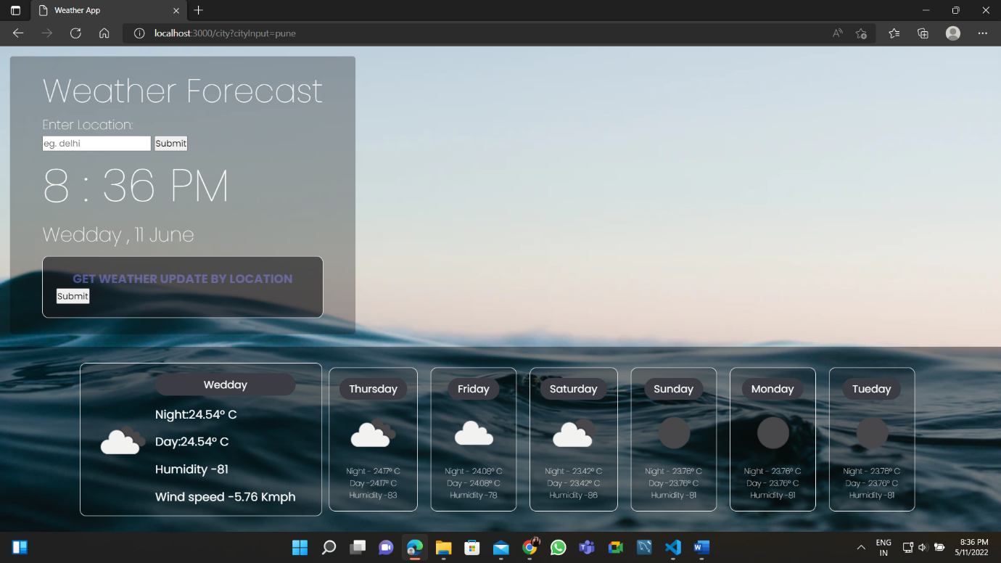

DATA USING LOCATION: 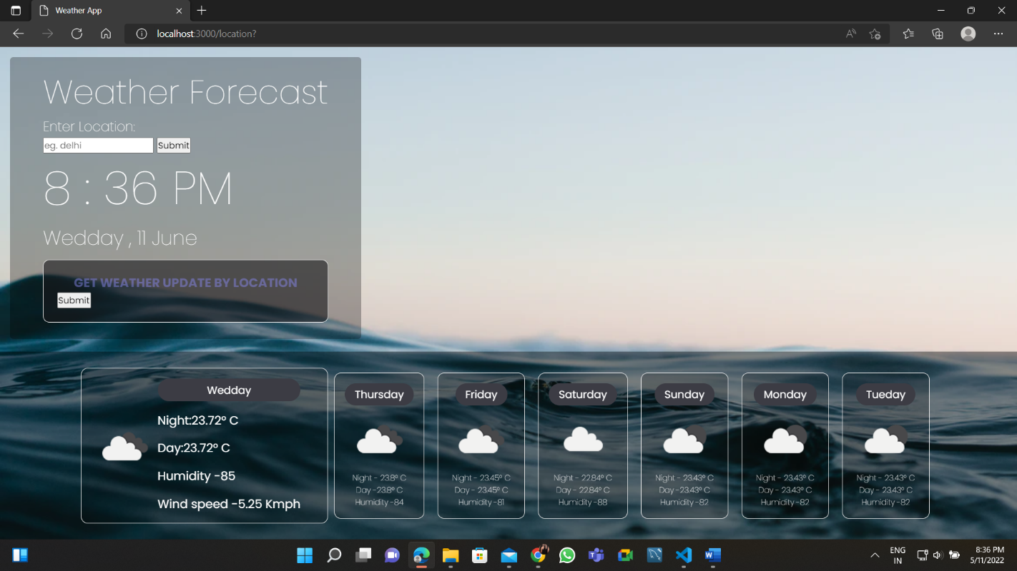

PLESE CONVEY IF ANY CORRECTION NEED AND RUNNING DATA: 😊

YOURS FAITHFULLY